**PRESS RELEASE**

**COMMUNICATIONS AND MEDIA TEAM OF THE 2023 ASEAN SUMMIT**

**No. 44/SP/TKM-ASEAN2023/ENG/5/2023**

**President Checks 42nd ASEAN Summit Rehearsal in Labuan Bajo**

**West Manggarai, 8 May 2023–** President Joko “Jokowi” Widodo is scheduled to check the 42nd ASEAN Summit rehearsal on his second-day working visit in Labuan Bajo, West Manggarai, East Nusa Tenggara, Monday, 8 May.

President Jokowi will review the ASEAN leaders' reception rehearsal in the Meruorah Hotel lobby in his first agenda. It will be followed by photo sessions of each ASEAN leader with President Jokowi and group photo rehearsals.

Then, the President will head to Komodo Ballroom at Meruorah Convention Center to inspect the 42nd ASEAN Summit main site. He will also review the ASEAN leaders' luncheon venue.

The agenda will be closed with a review of the ASEAN leaders' dinner rehearsal at Ayana Komodo Waecicu Beach in the evening.

Meanwhile, First Lady Iriana Joko Widodo is also scheduled to review the ASEAN leaders' spouse program.

ASEAN leaders will discuss several crucial issues to create a stronger region in facing challenges and strengthen the ASEAN economy. This effort is in line with the theme carried out in Indonesia's chairmanship: ASEAN Matters: Epicentrum of Growth. (Setpres/TR/Elvira/FLW)

***

For more information, please contact:

**Director General of Public Information and Communications of the Ministry of Communications and Informatics - Usman Kansong (0816785320)**

Get more information at <http://asean2023.id>, <https://infopublik.id/kategori/asean-2023>, and <https://indonesia.go.id/kategori/ragam-asean-2023>

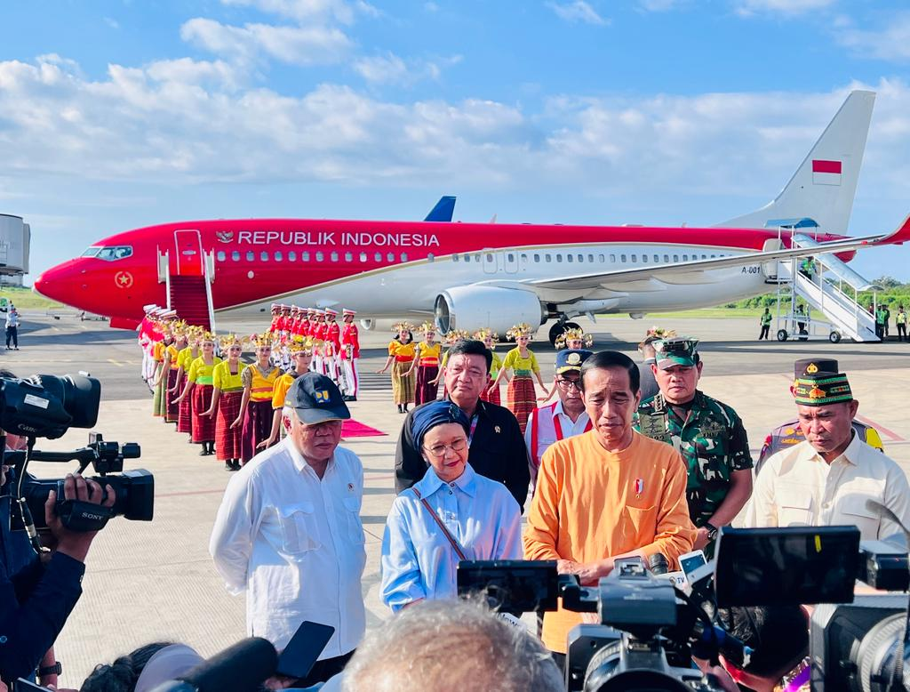

President Joko Widodo delivers his statement to the media at Komodo International Airport, West Manggarai Regency, East Nusa Tenggara Province, on Sunday, 7 May 2023. (Photo: BPMI)